**FIGURE 1** Airport subsidies and subsidized airport number statistics (2013-2017)

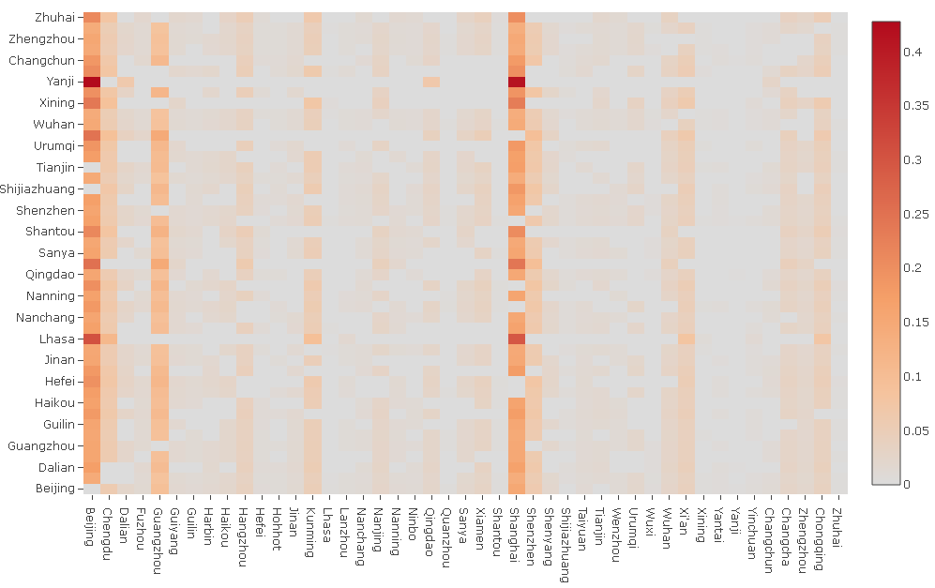

**FIGURE 2** Heat map of the spatial weight matrix ***W***

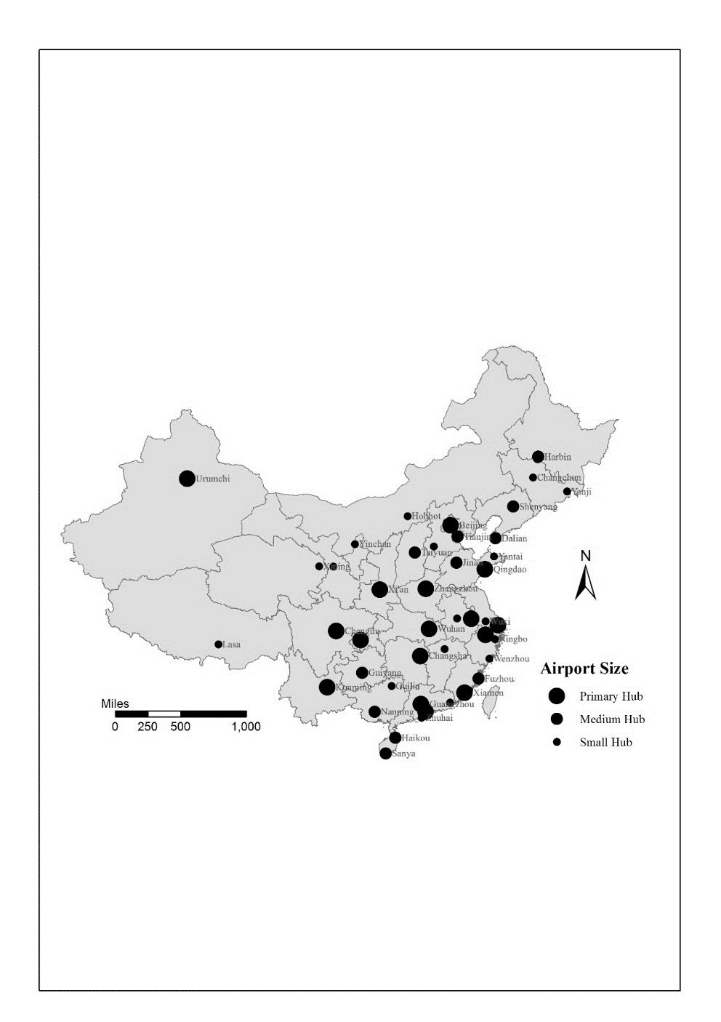

**FIGURE 3** A general view of the 45 sample hub airports in China mainland. Note: The three categories of hub airports are defined by their percentage of the national annual passenger throughput, i.e. Primary hub airports owning more than 2%, Medium hub airports(1%-2%) and Small hub airports(lower than 1%).

**FIGURE 4** Annual percentage of throughput of the sample airports over national output.

|  |  |
| --- | --- |
|  |  |
| (a) | (b) |

**FIGURE 5** Moran scatter plots (GDP and air passenger traffic, 2014. **Data sources**: China City Statistical Yearbook and Statistical Data on Civil Aviation of China